Table Top Classic
(rule version 20190118.00)

Objective: The robot begins behind a starting line that is 18 inches from the edge of the table. The contest consists of three tasks. The first task is to drive to the opposite side of the table and have some part of the robot stick out beyond the edge, and then return past the starting line. The second task is to knock a soda can off the table. The third task is to push a soda can into a box that is hanging along the edge of the table at a specific location (see diagram). All the soda cans on the table will be covered with fluorescent orange tape. The table top has no edge protection so robots must take measures to avoid falling off. The more tasks completed the higher the robot’s score.

Robot: Competing robots must run autonomously but are not required to be self-contained. All sensors must be mounted on the robot. Robot length and width is limited to 18x18 inches and may not become larger than this size at any stage of the contest. Maximum robot weight is 5 pounds.

Self-Contained Definition: Self-contained means that all computing power used to run the robot is carried on the robot platform.

Run Definition: A run starts when the robot is placed behind the start line of the arena, given a signal from the judge, and moves. If the robot fails to move, the competitor can remove the robot and try again at the end of the round. If the robot doesn’t move when given this 2nd chance, its run is forfeited. The run ends whenever the robot completes the tasks, or malfunctions after moving, or falls off the table, or 5 minutes has elapsed. Each robot is allowed 1 run per contest round.

Round Definition: A round consists of a single run by each competing robot. The competition consists of 3 rounds.

Play: At the start of the competition, the robot may be placed anywhere behind the starting line. The robot may be turned to any angle when initially placed.

The judge will place two cans on the arena. The locations will be marked with small pieces of blue tape so that all competitors see the same field.

The robot must perform 3 tasks:
- Cross the table and hang a portion of the robot over the edge opposite the starting line, then return past the starting line.
- Knock a soda can off the table.
- Place a soda can into the box hanging along the edge of the table (see diagram).

The tasks can be executed in any order. Any of the available cans can be used for any task.

Beacons or other navigational aids either in or outside of the arena are not allowed.

Course: The arena is the same platform used in the Big Table Top 2 contest. It consists of a 60x72 inch platform made of two pieces of plywood painted white (each piece ~36x60 inches). There is a seam that runs between the center of the narrow sides of the platform. It is covered with either white or blue tape. There is a starting area (18x18 inches) that is not used by this contest outlined in black tape. This contest uses a starting line marked in blue painter tape that crosses the platform along the edge of the black outlined starting area. A ~14x9x5 inch box (size of large shoe box) is hung at the opposite corner of the starting area 12 inches from the enc of the table. The 14-inch side of the box is located along the side of the platform. See diagram for layout details.
Start Line
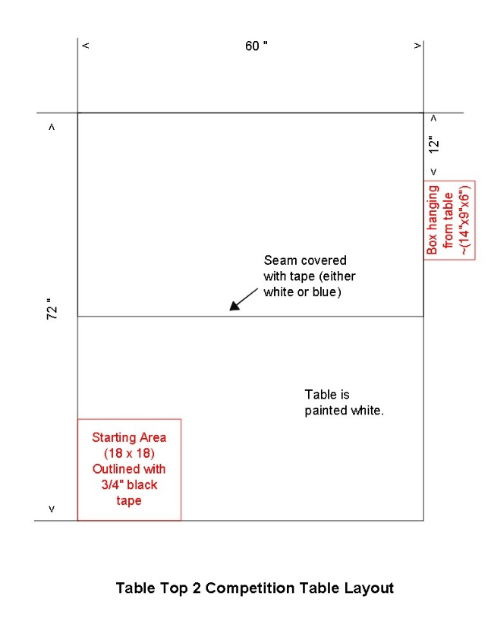

Can Specifications: The cans used in this contest are empty standard 12-ounce aluminum soda cans wrapped in 1 or 2 layers of fluorescent orange duct tape. The tape used is Duck Brand Model #1265019 Neon Colored duct tape. It is available at Walmart, Home Depot, Staples and Amazon. The pull tabs may or may not be removed.

Scoring: A robot’s run score is the sum of the number of tasks completed within the time limit. The top three scores will be awarded 1st, 2nd, and 3rd place in the competition. If multiple perfect scores are achieved, the fastest run time will be used to determine the winner. If no perfect score is achieved and there is a tie in the number of tasks performed, the tied contestants will each make an additional run with the single task of pushing a can off the table. The judge may adjust the cans locations before this run. The robot that completes the task fastest gets the highest placement. The other robots will be ranked on the speed that they complete the task. If some or all the robots fail to complete the task, they will determine their rank between themselves by coin toss. Time limit for this run is 3 minutes. No place or prize will be awarded to a robot that doesn’t at least complete one task during the competition.

A perfect score is 3.

Judging: One or more judges will referee the contest. They will ensure the rules are followed and impose scoring penalties. A robot deemed unsafe or not complying with the rules will be removed from the competition. The decisions of the judges are final.

Acknowledgment:
This contest is a modified version of a competition originated by the Home Brew Robotics Club and found on www.robogames.net.

